### **ONLYFANS CONTENT STRATEGY**

In this lesson, you will learn:

* What are the 5 different types of content formats we use on OF
* How our chatters team help you make more sales
* How to make more sales with your content
* How to create great content for each format

**THE 5 DIFFERENT CONTENT FORMATS FOR ONLYFANS**

There are **5 types of content** on Onlyfans.

* Sequences
* Picture Sets
* Long Form Videos
* Short Form Videos
* Text & Voice Messages

**TEXT MESSAGES: YOUR TEAM OF CHATTERS**

On OF, we can **chat directly with your fans**.

Chatting is super important as it helps **build a connection with your subscribers** giving them the feeling that they’re getting to know you at a personal level… so they want to **buy extra exclusive content from you**, on top of their subscription!

For creators who are ableto generate traffic, we add chatters who work on your OF Profile.

Of course, that is not something you should tell your followers… they should think the messages are coming from you ;)

**RELATING YOUR CONTENT TO MAKE MORE SALES**

For Sequences, Picture Sets, Long form and Short form videos: each week, try to **relate them to each other**.

What does this mean? Use the **same or similar lingerie/outfits/location in all content pieces in one week.**

Why? Because all of it can be **used for sales** **together**:

* A Big Spender might buy at one time a picture set, then a sequence, then a short-form video, and then 2 long-form videos **if the chatter** (who’s trying to make sales) can **put together a storyline between these content pieces**. They can do that if **all the content pieces have something connecting them**.
* Simple Example: *You choose to create content this week in blue jeans and red lingerie: use that outfit in every content piece you create for that week.*
* The difference between **unconnected content and connected content**? One could bring in max 300$ from a great chat, the other max 700$ from a great chat.

## 

## **CONTENT FORMAT 1: SEQUENCES**

**Example topics that you can create sequences about:**

* Showering
* Bathing
* Going to bed
* Cooking
* Watching TV
* Morning Wake Up
* Lingerie Sets
* Living Room
* Kitchen
* Netflix
* Date night
* Secretary
* Maid

**Sequences have four parts:**

1. Tease
2. Warmup
3. Main Videos
4. Conclusion

* **Each part is an important step of the sequence**; it must not be skipped when it comes to selling in chats.
* Each step complements the next step, meaning that **each part is an upsell to the previous one**, and **each video gets sold for a higher price**.
* The first videos are just as important as the last ones:
  + Selling something for 95$ is hard. But if the subscriber already bought something for 15$, then 35$, then 50$, then 75$ then he can't wait to see what comes next, he needs to buy it.
  + Our **chatters team knows how to sell the content** and deal with the **psychology of selling** perfectly, you just have to make sure it fits the exact format laid out here.
  + Miss something and your sales won't work as well.

### **Sequence part 1: Tease**

* **Content:** 3 Pictures
* **Goal:** These pictures will be sent in chat to hook people that new content is available.
* **Example: Cooking-themes Sequence Teasers:**
  + In the “Tease”, show that you will cook and make it slightly sexy - not yet revealing
  + For example, wear tops and tight bottoms in this part - your goal is **not to reveal too much at the beginning**. Your booty or boobs might be visible in tight clothes, but not naked. Example photos:  
    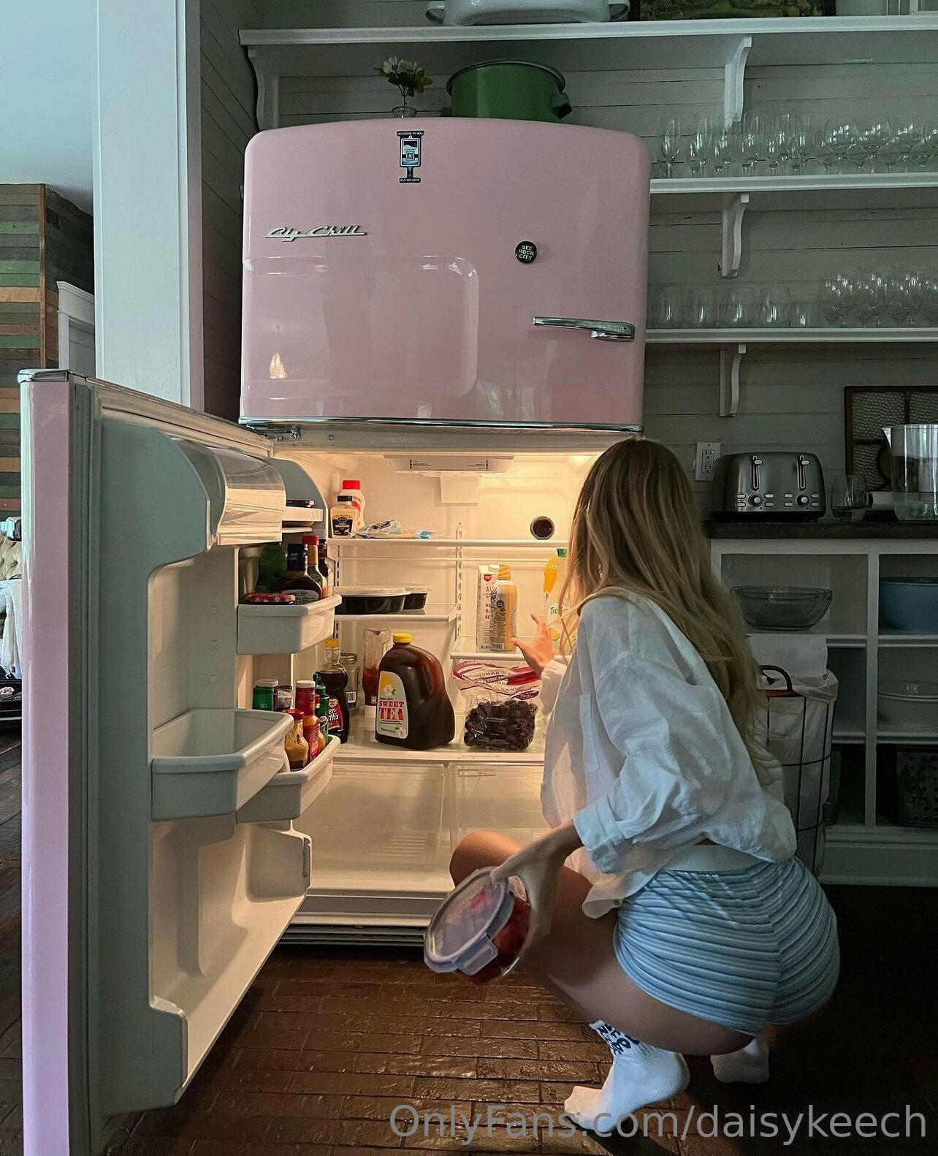
* **Naming Files:** Name the images as 'Tease 1', 'Tease 2', 'Tease 3'

1. **Sequence part 2: Warmup**

* **Content:** 5 Pictures
* **Goal:** Pictures sent to the customer once it's confirmed that he's available to chat and purchase now. Gets them excited and they want to see what the next content piece will be.
* **Example: Cooking-themes Sequence Warmups:**
  + You portray the idea of the cooking process in an outfit that is used in videos, for example, both lingerie and apron.
  + Example photos:  
    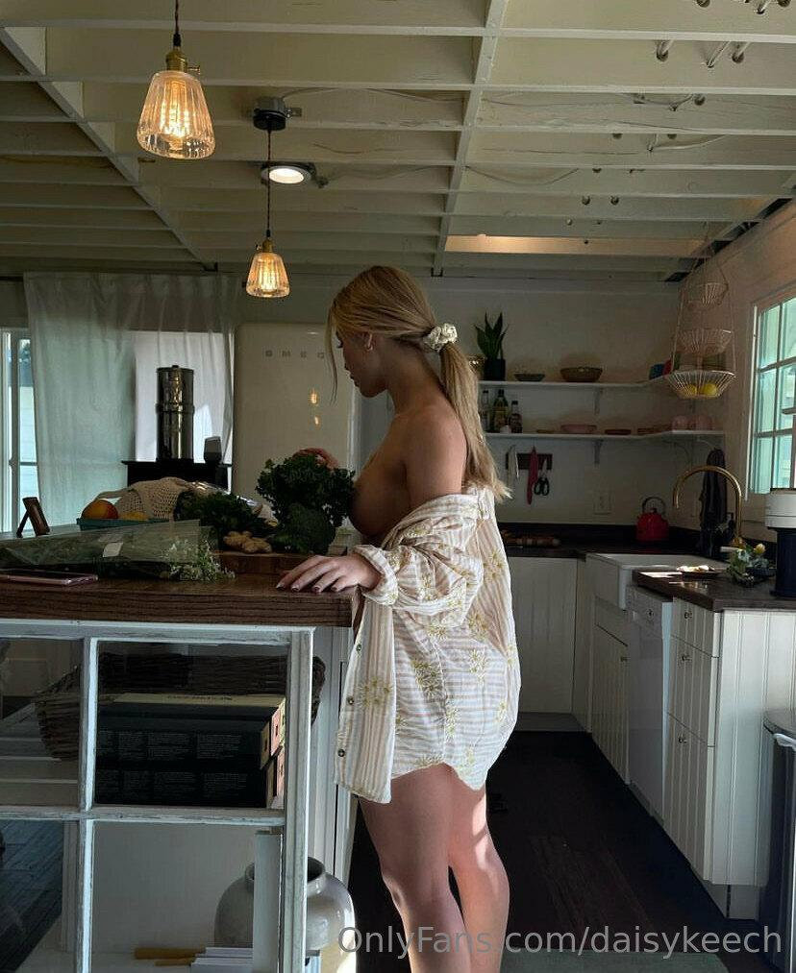
* **Naming Files:** Name the images as 'Warmup 1', 'Warmup 2', 'Warmup 3', 'Warmup 4', 'Warmup 5'.

### **Sequence part 3: Main Videos (Engaged in Full Action)**

* **Content:** 5 Videos
* **Goal:** These videos are what sells. Each video gets sexier and longer.   
  The subscriber knows **the next video will show mor**e, so he will **keep buying more**.
* **Duration:** Minimum time requirement for each video:
  + Video 1 Duration: 45 seconds
  + Video 2 Duration: 60 seconds
  + Video 3 Duration: 90 seconds
  + Video 4 Duration: 100 seconds
  + Video 5 Duration: 120 seconds
* **Structure:**Don't take off clothes between the videos, make sure to include that in the video.
  + Video 1: Clothed - Some lingerie can be visible
  + Video 2: In Lingerie - Some clothes can be visible
  + Video 3: In Lingerie - No Clothes
  + Video 4: In Lingerie/Topless/Nude - No Clothes
  + Video 5: In Lingerie/Topless/Nude - No Clothes
* **Naming Files:** Name the videos as 'Main 1', 'Main 2', 'Main 3', 'Main 4', 'Main 5' in the corresponding order.

### **Sequence part 4: Conclusion (Satisfaction Post Action)**

* **Content:** 3 Pictures, 1 video
* **Goals:** These pictures/selfies are used to show the subscriber how great the chat was and how **“happy you are about the conversation**”.   
  Make sure to put effort into these. Everyone wants to feel nice about the purchase they made - it sets them up for a **repeat purchase** of the next sequence to be sold.
* Film a 10-15 second video saying what a great experience that was and thank the subscriber for the adventure
  + For example:
    - “Thanks baby, this was exactly what I needed today. Love you” and blow kisses
    - “Wow, i haven’t finished that good in a while, you really got me going there, i can’t wait to go again”
    - Or other similar texts
* **Example: Cooking-themes Sequence Conclusions:**
  + Be happy, smile, show what you made

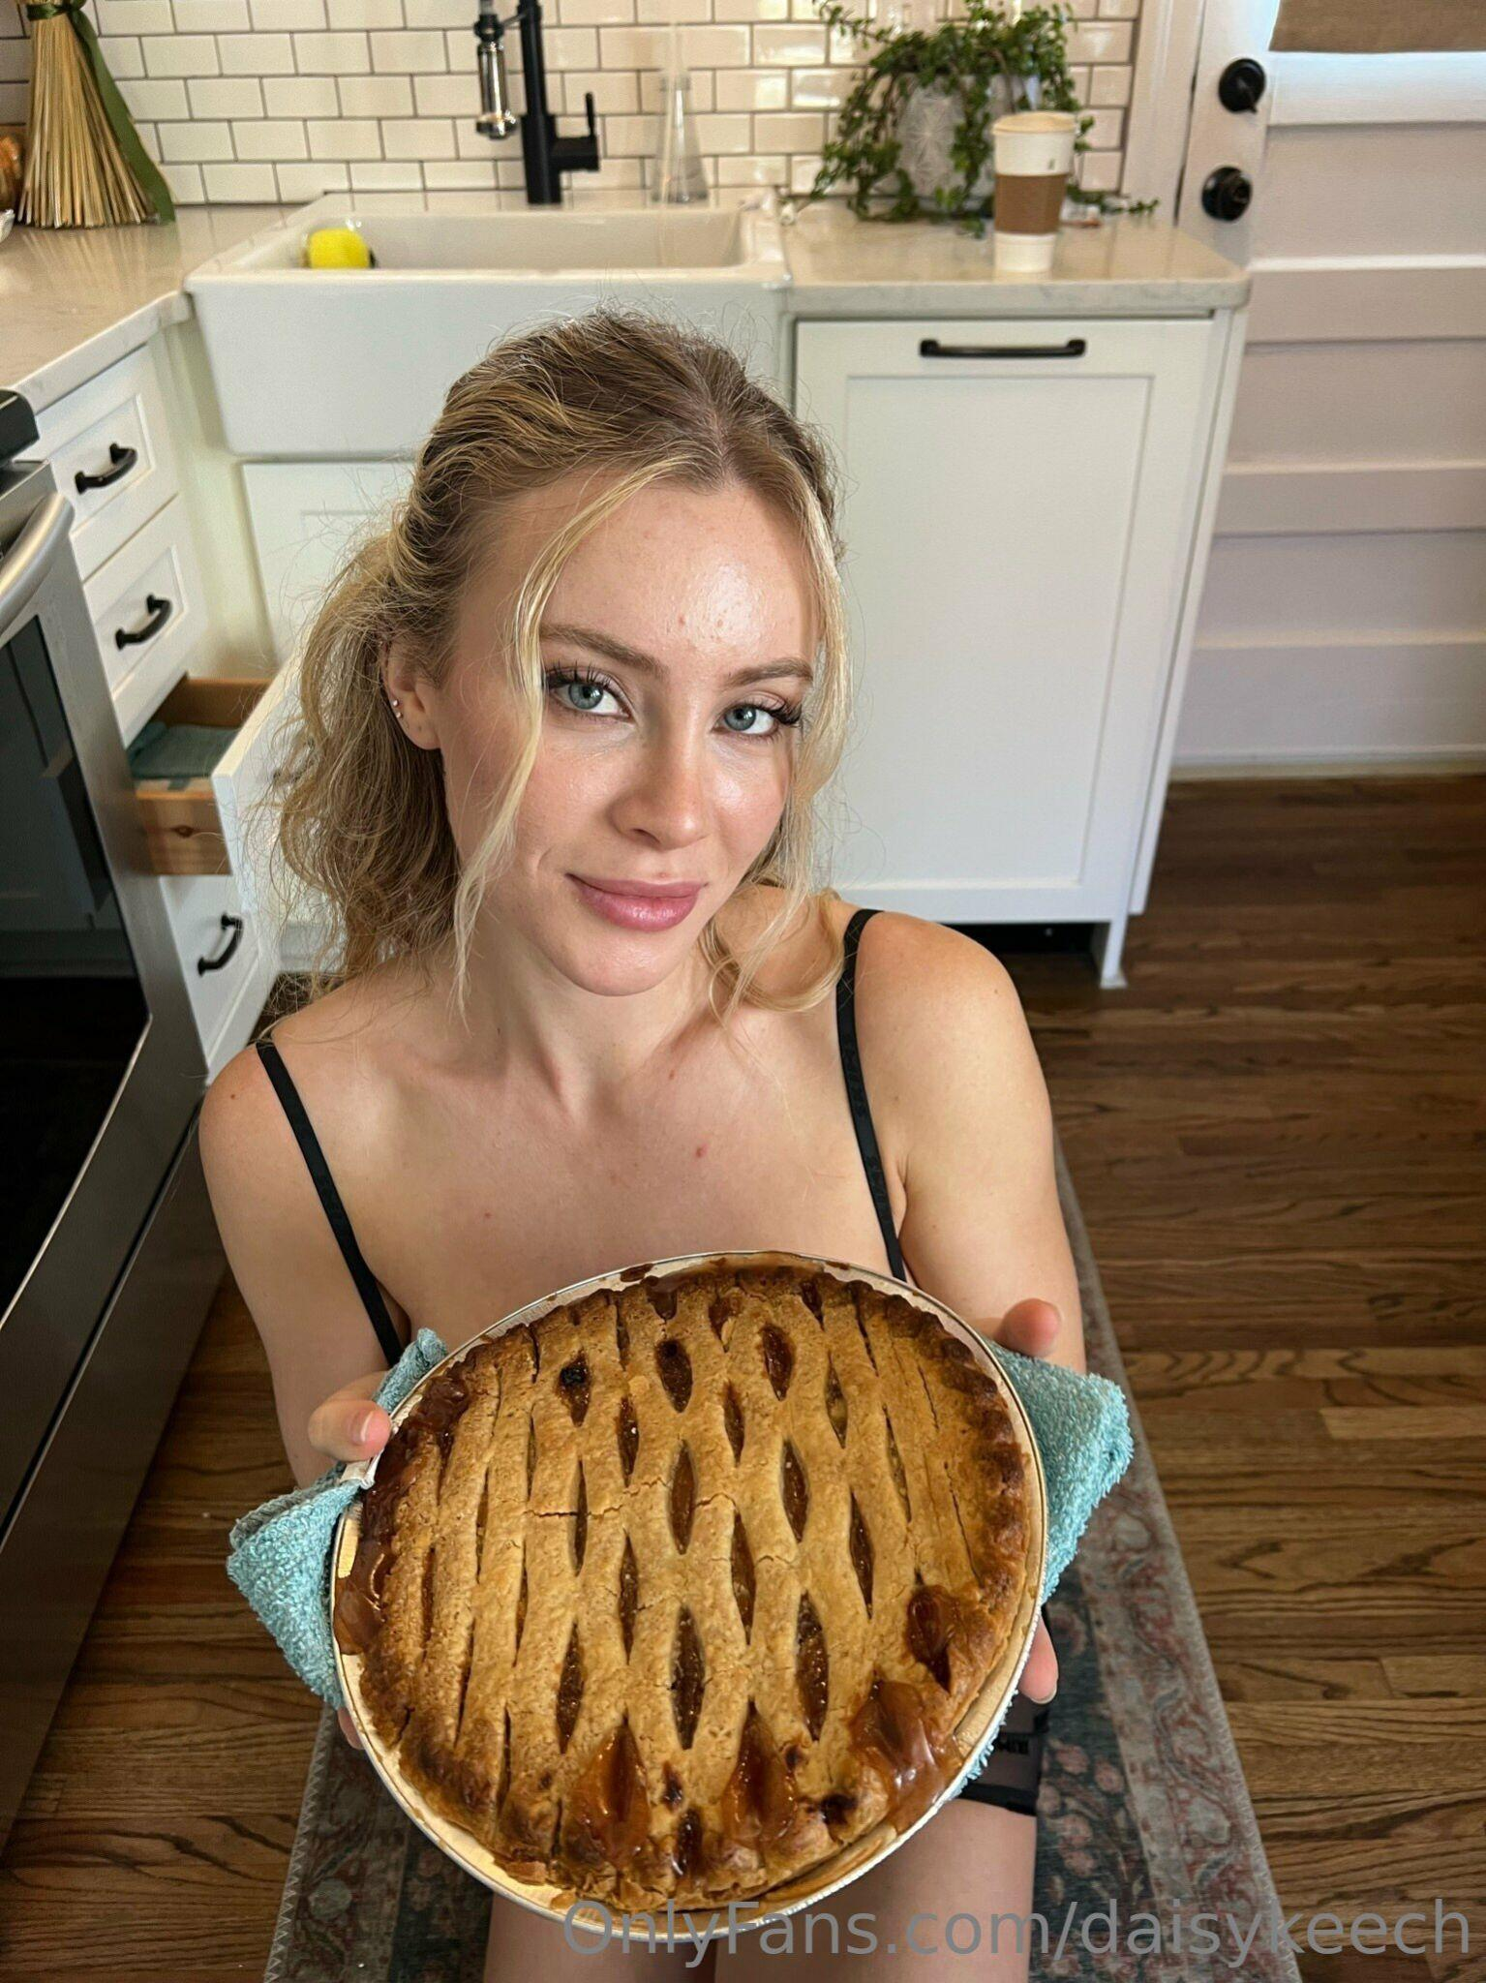

* **Naming Files:** Name the images as 'End 1', 'End 2', 'End 3' in the corresponding order. Name the video as “End Video”

Make sure to always follow the **structure** written above!

## **CONTENT FORMAT 2: INDIVIDUAL PICTURES**

**These pictures will be used in 4 ways mainly:**

* + For the feed
  + For Mass message sales
  + For Sequence sales
  + For Relationship building

**Every week create 15 Pictures:**

* **10** of those should be a **picture set.** 
  + All of these pictures should be taken together. These are always sexy picture sets. Lingerie/Bikini/Topless etc…
* **5** Of these should be **pictures from your life**
  + Selfies while walking, pictures of you cooking, pictures of you on the phone, walking your pet, doing your laundry etc….
  + These are needed to show your life and be used for relationship building between sales.

## **CONTENT FORMAT 3: LONG FORM VIDEOS**

**Goal:** These videos are always sexy videos of you doing different things in your life.

* You can make any part of your life in a sexy way
  + You doing the laundry
  + You reading a book
  + You talking about your day
  + You unpacking your shopping bag
  + You trying on new outfits
  + You stretching after a workout
  + You posing in an revealing outfit with a nice background
* Check the examples below, you will find plenty of examples to recreate.

**Every week create 3 Videos**

**Duration:** In a range from 2 to 5 minutes, longer videos sell better.

## **CONTENT FORMAT 4: SHORT FORM VIDEOS**

**Goal**: Similar to long form videos, just shorter.

* Remember - If you keep filming similar videos over and over, people will get bored of buying.
* Each week, come up with new ideas to create.
* Traveling? Great, film in the plane toilet
* Going for a hike? Great, flash your booty.
* Shopping for new lingerie? Great, film it in the dressing room.
* Lifestyle short video - Gym, walking, eating, hiking

**Every week create 10 Videos:**

* **5** In Lingerie
* **5** From Life

**Duration:** From 15 seconds to 1 minute

## **CONTENT FORMAT 5: VOICE MESSAGES**

**Goals:** Voice messages are the perfect way to get subscribers excited.

* It's more **personal** than a written message, they hear your voice.
* They **can't wait to get another one**, will try to act good for it (buy more, or send you $$$ tips)
* The next thing they'll want to see is a photo or a video
  + That's where all the pictures and videos you create come in and start selling.
* **Voice messages are not sold** themselves, but very successfully to **initiate chats** with subscribers set up the sales.

Here is a list of voice messages to be created. Each week create **10** voice messages, starting from the top.

* Tip: Feel free to modify the text of each voice message. You can make them more personalized, just make sure to hit the 10 voice messages/week.